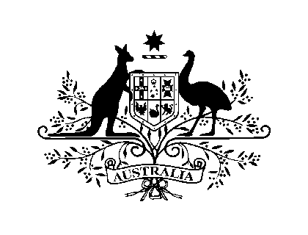

**AUSTRALIAN HIGH COMMISSION, NAIROBI – PRESS RELEASE**

**AUSTRALIAN AMBASSADOR PRESENTS CREDENTIALS TO SOMALIA’S NEW PRESIDENT**

Australia’s Ambassador to Somalia, HE Geoff Tooth presented his credentials to Somalia’s President HE Hassan Sheikh Mohamud at Villa Somalia in Mogadishu on 20 November. Ambassador Tooth is the first Australian Ambassador to present credentials to Somalia.

Ambassador Tooth was also delighted to have the opportunity to meet new Deputy Prime Minister and Minister of Foreign Affairs, Fowsiya Yusuf H Adan, a day after she was sworn into the position.

Ambassador Tooth congratulated Somalia on its recent peaceful political transition. “Australia shares the optimism of the international community that this is a major milestone for Somalia, and believe that further important steps towards stability and security will be made under the leadership of the President and his new Cabinet”.

“The President has outlined to me his priorities for Somalia going forward in terms of security, justice and economic recovery. Australia looks forward to playing a constructive role in supporting security and stability in Somalia through membership of the UN Security Council and Australia’s humanitarian aid program.”

Australia and Somalia have strong people-to-people links, with a Somali diaspora in Australia of around 8000 people.

Australia has contributed $4.5 million to AMISOM and was among the five largest donors to the Horn of Africa humanitarian crisis in 2011, providing more than $61 million in development assistance to Somalia.

Australia has also contributed over $4.3 million since 2009 to support the United Nations Office on Drugs and Crime (UNODC) regional counter-piracy program.

HE Geoff Tooth, Australian Ambassador to Somalia

22 November 2012